**Covid Case Using DataBricks**

**Reading the file using python in DataBricks:**

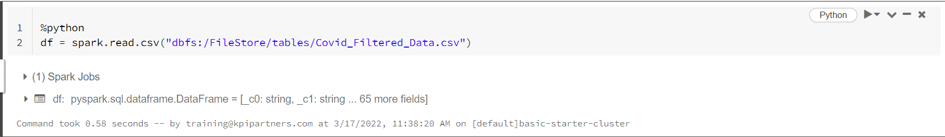

**Creating Temporary View:**

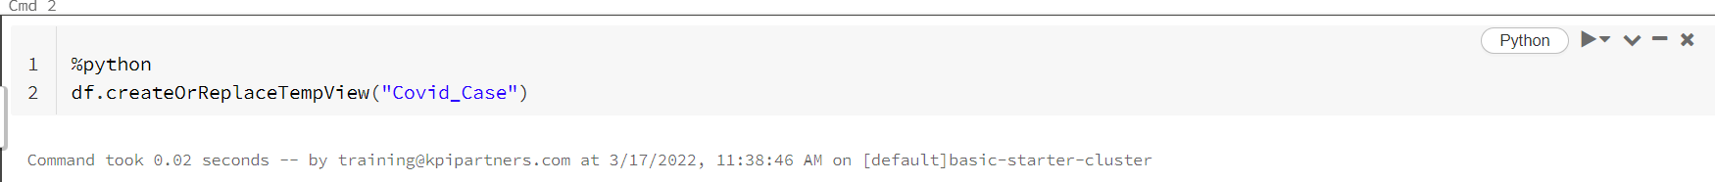

**Queries using SQL:**

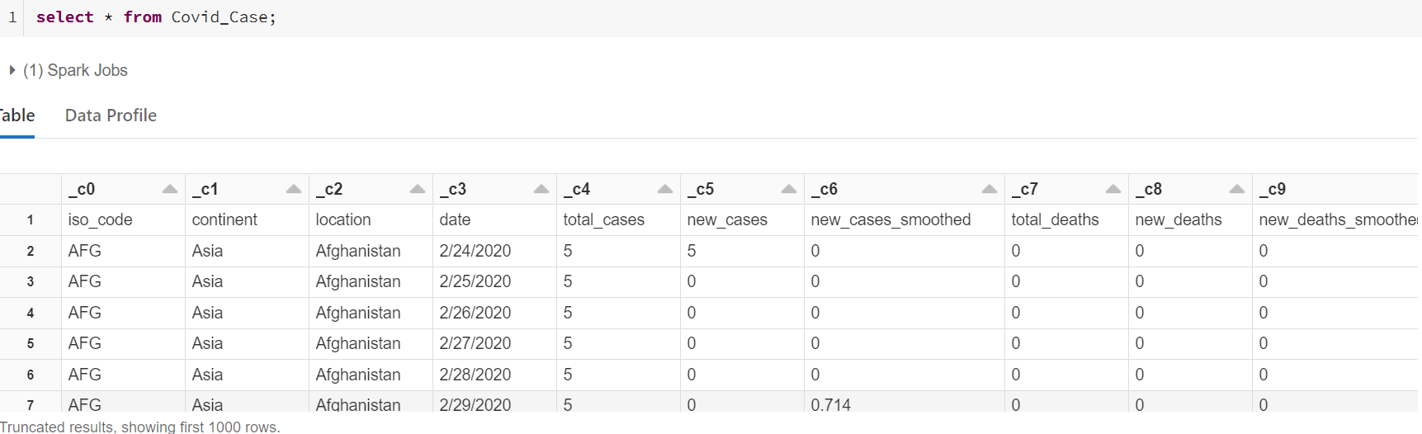

**3. Positivity rate where the strigency index is maximum.**

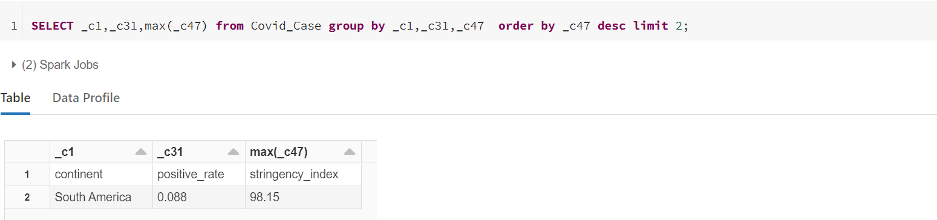

**4.** **Which continent and location having max of deaths and male_smokers.**

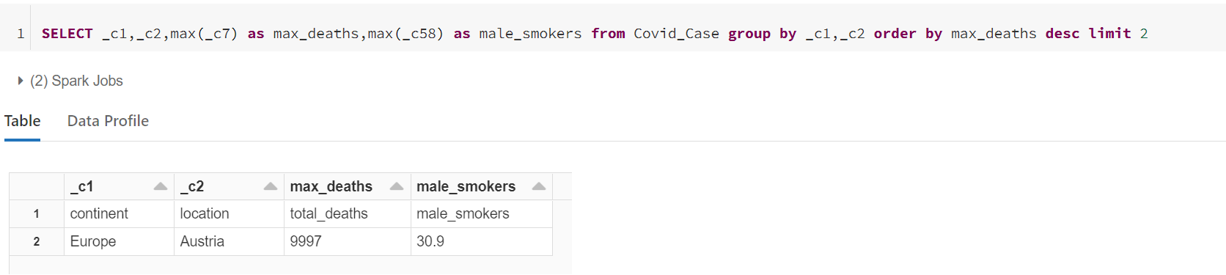

**5. Which year having the highest number of deaths.**

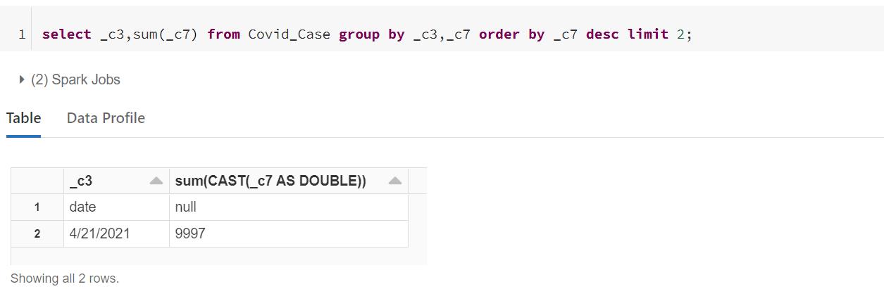

**6.** **Which location having lowest recovery rate for each continent.**

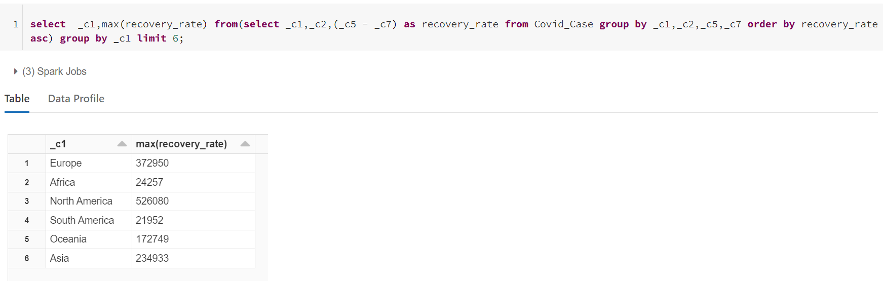

**7. Countries with max cardiovasc_death_rate and diabetes_prevalence greater than 10.**

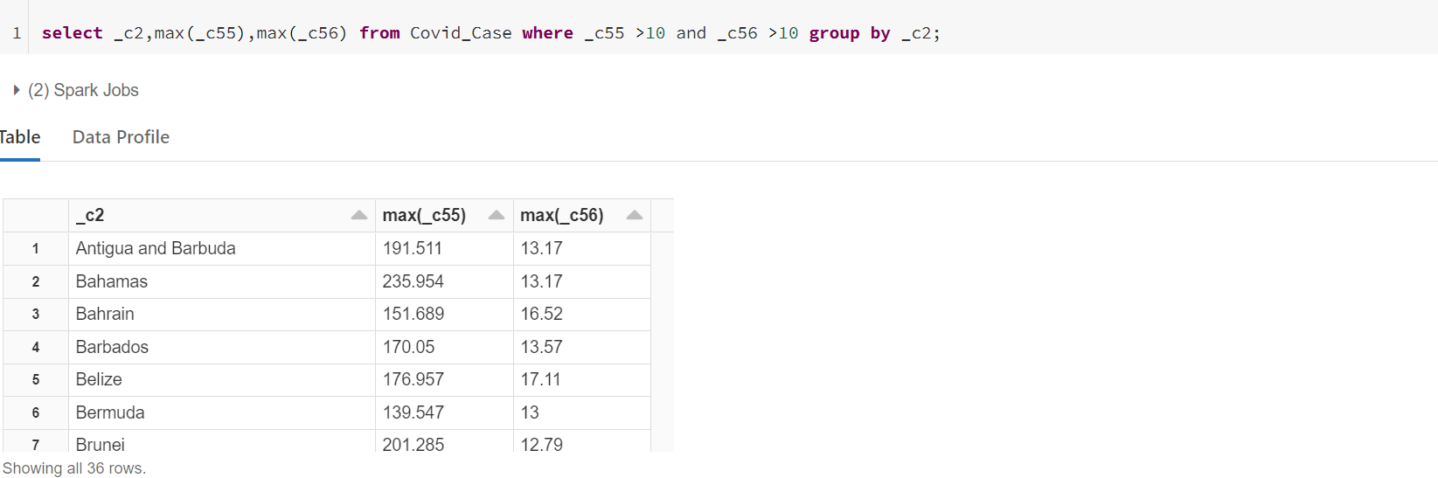

**8. Which location has highest number of vaccinated people in each continent.**

